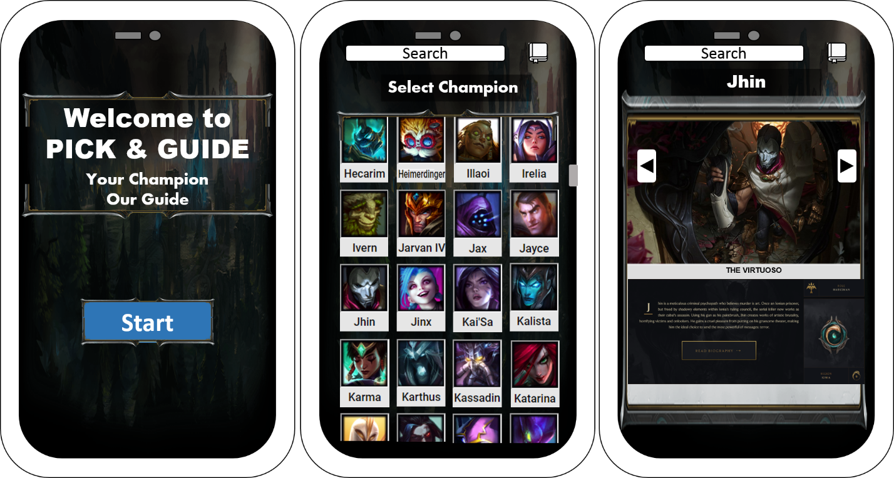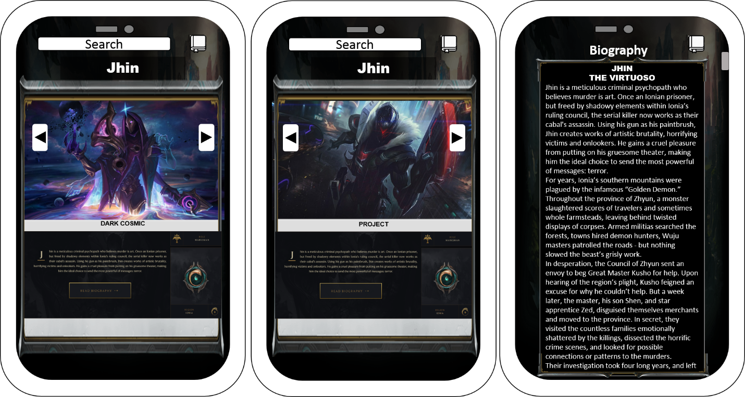

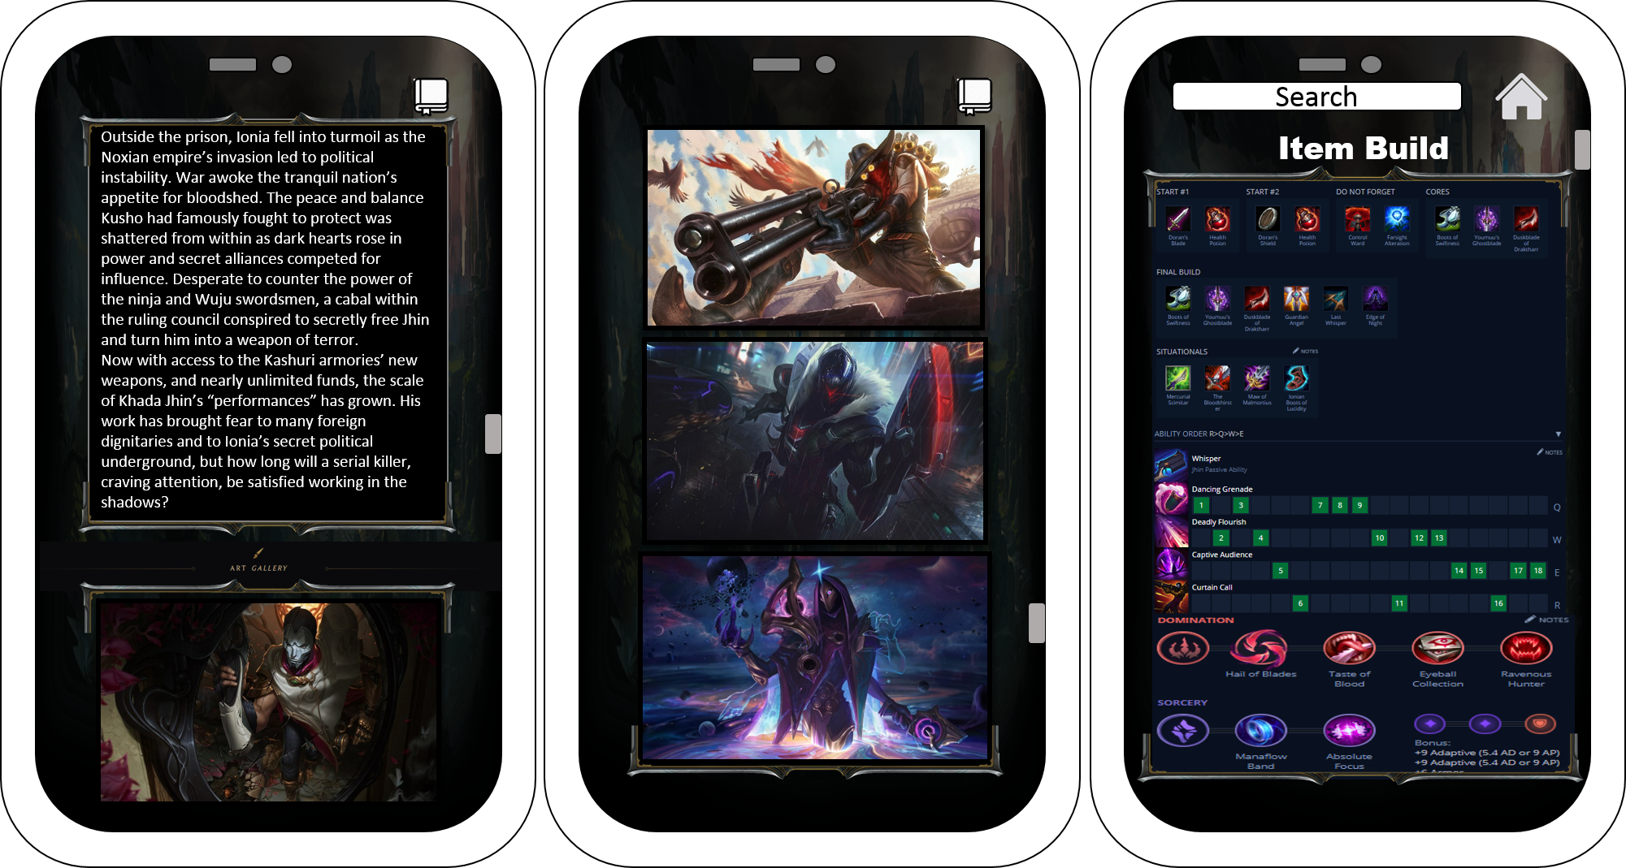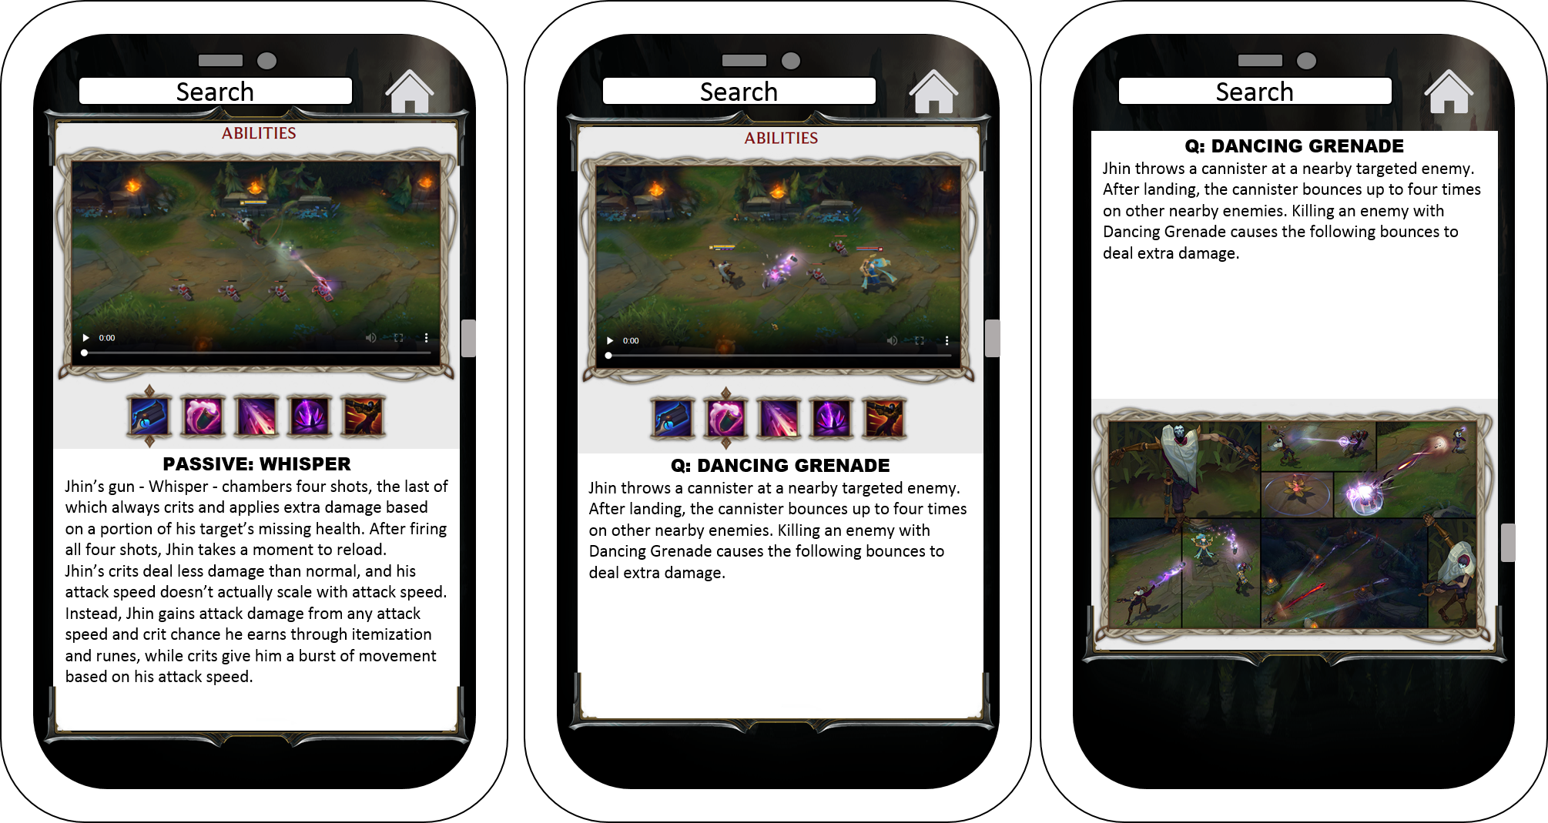

Principles of HCI

Know the User

My application helps those who wants to learn more about their champions. This app is easy to navigate and has a lot of info about the champions builds and lore. My application targets the audience that have little to no knowledge about league of legends champion lore and build. Its full of info at the same time can be easily use by anyone who plays league of legends.